**Practical No. 10**

1. **Write a program to perform validation of a form**

**and to implement Error Handling in AngularJS**

**Code:**

**FormValidation.html**

<html>

<head>

<title> AngularJs Form Validation </title>

<script src="angular.min.js">

</script>

<script>

var app = angular.module('formApp', []);

app.controller('formCtrl', function ($scope) {

$scope.sendForm = function () {

window.open("RecordSubmit.html");

$scope.msg='Form Submited Successfully';

};

$scope.getClass = function (color) {

return color.toString();

}

});

</script>

<style>

.valid.false {

background: red;

}

.valid.true {

background: green;

}

.error {

color: red;

}

</style>

</head>

<body ng-app="formApp" ng-controller="formCtrl" bgcolor="pink">

<h3>Form validation demo app in AngularJs</h3>

<form name="personForm" ng-submit="sendForm()">

<label for="name">Name</label>

<input id="name" name="name" type="text" ng-model="person.name" required />

<span class="error" ng-show="personForm.name.$error.required"> Required! </span> <br /><br />

<label for="address">Address</label>

<input id="address" name="address" type="text" ng-model="person.address" required />

<span class="error" ng-show="personForm.address.$error.required"> Required! </span><br /><br />

<label for="contact">Contact No</label>

<input id="mobile" name="mobile" type="number" ng-model="person.mobile" required />

<span class="error" ng-show="personForm.mobile.$error.required"> Required number! </span>

<span class="error" ng-show = "personForm.mobile.$error.mobile"> Invalid mobile! </span> <br /><br />

<label for="email">Email</label> <input id="email" name="email" type="email" ng-model="person.email" required />

<span class="error" ng-show="personForm.email.$error.required"> Required!</span>

<span class="error" ng-show="personForm.email.$error.email"> Invalid Email!</span> <br /><br />

<input type="checkbox" ng-model="terms" name="terms" id="terms" required />

<label for="terms">I Agree to the terms.</label> <span class="error" ng-show="personForm.terms.$error.required">You must agree to the terms</span> <br /><br />

<button type="submit">Submit Form</button> <br /><br />

<span>{{msg}}</span>

</form>

</body>

</html>

**RecordSubmit.html**

<html>

<head>

<title>Welcome Page</title>

</head>

<body bgcolor="yellow">

<h1>Record Successfully Submited............</h1>

</body>

</html>

**Output:**

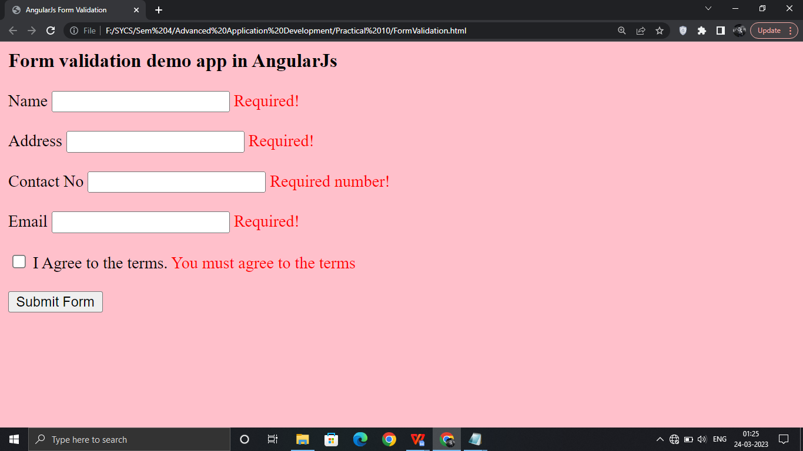

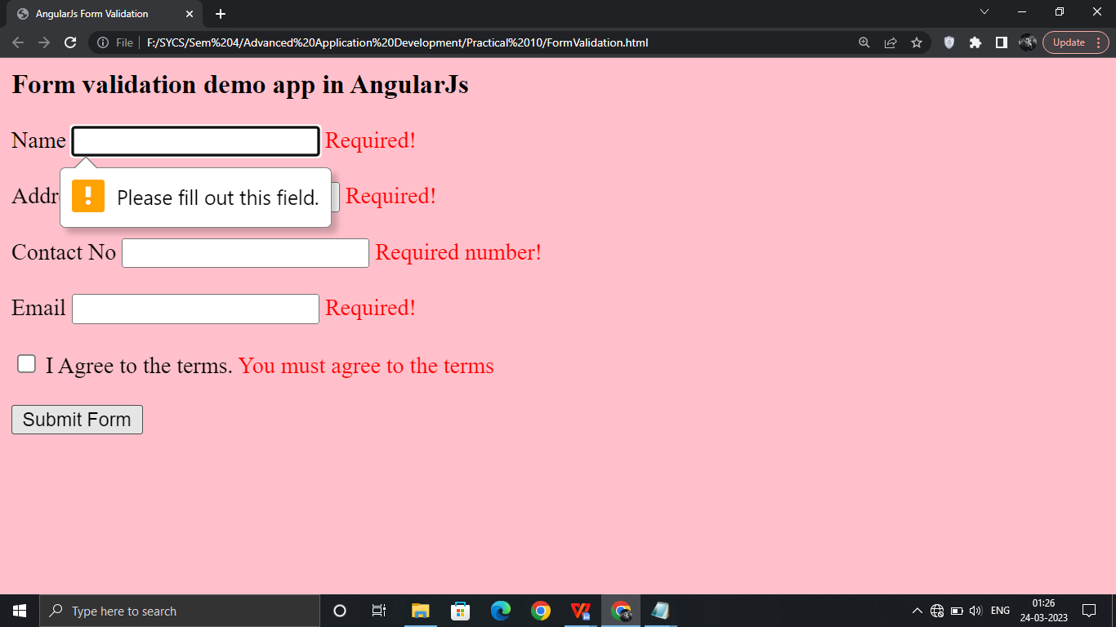

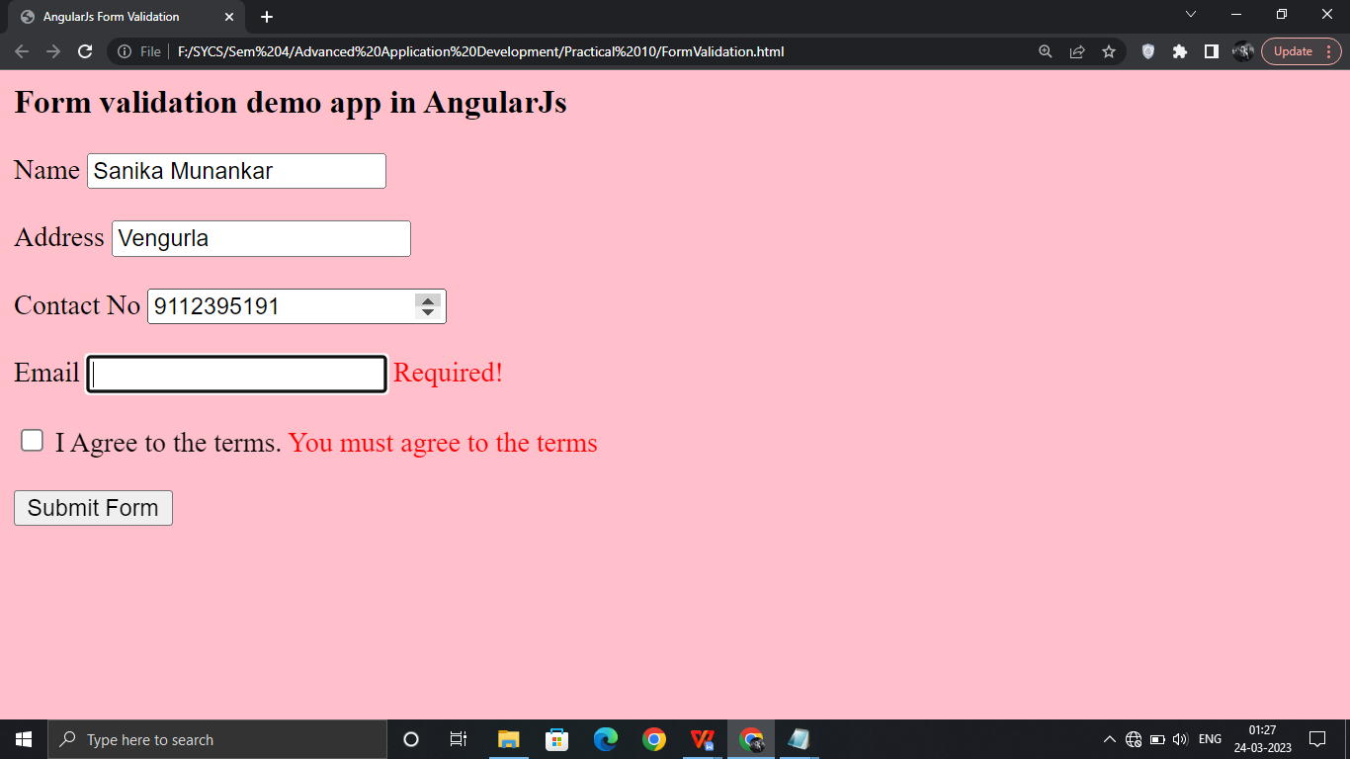

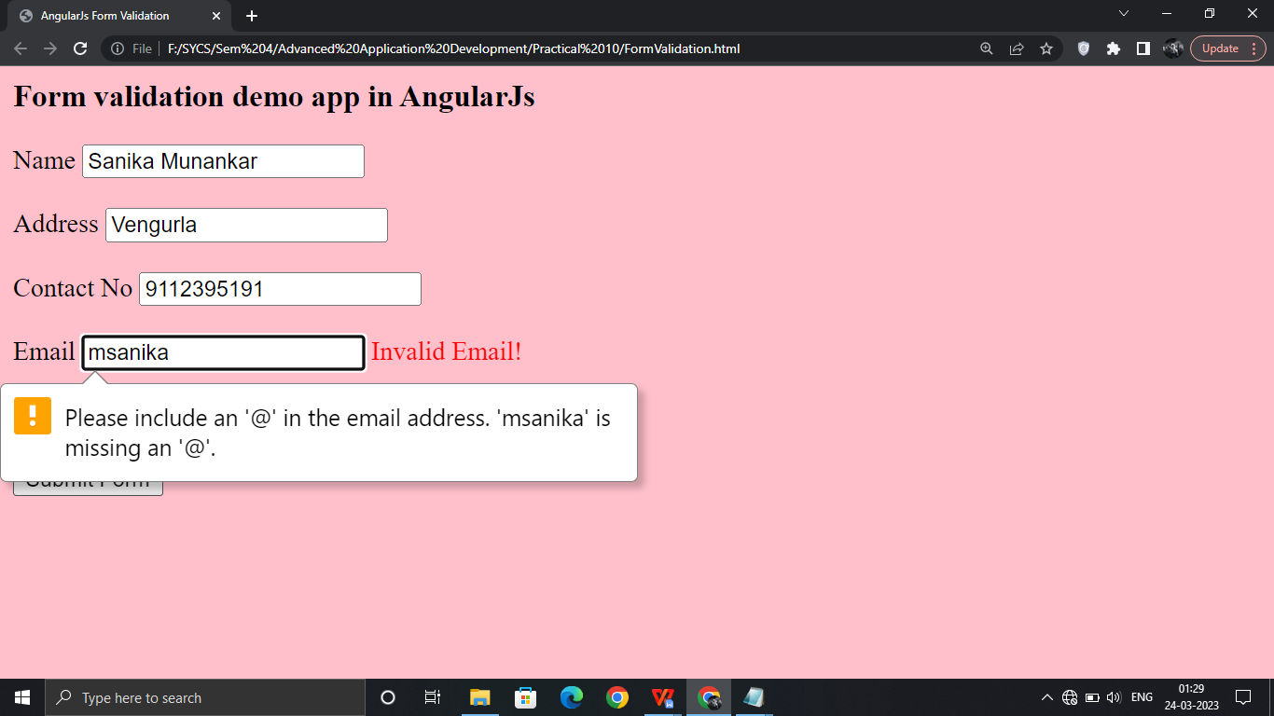

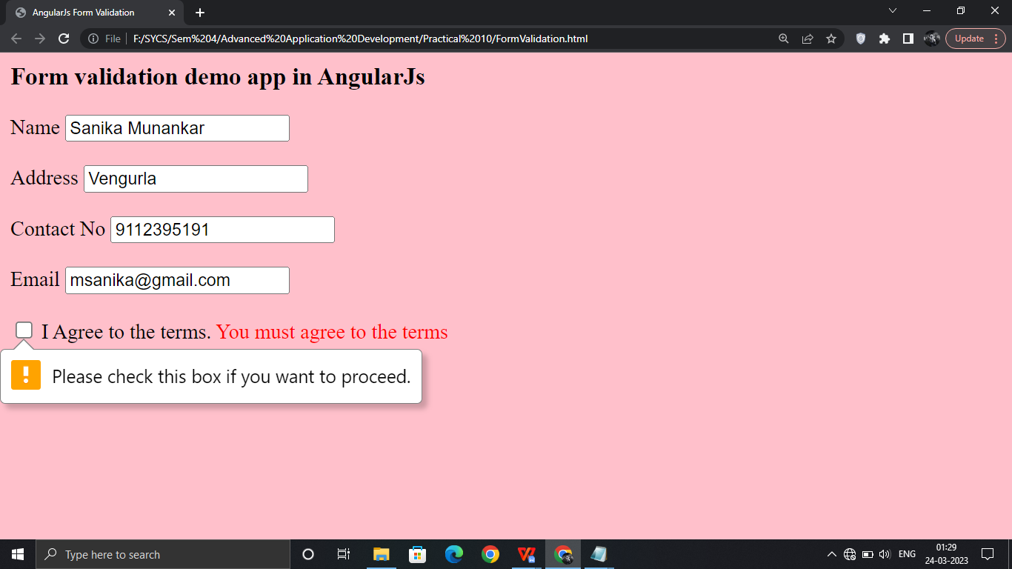

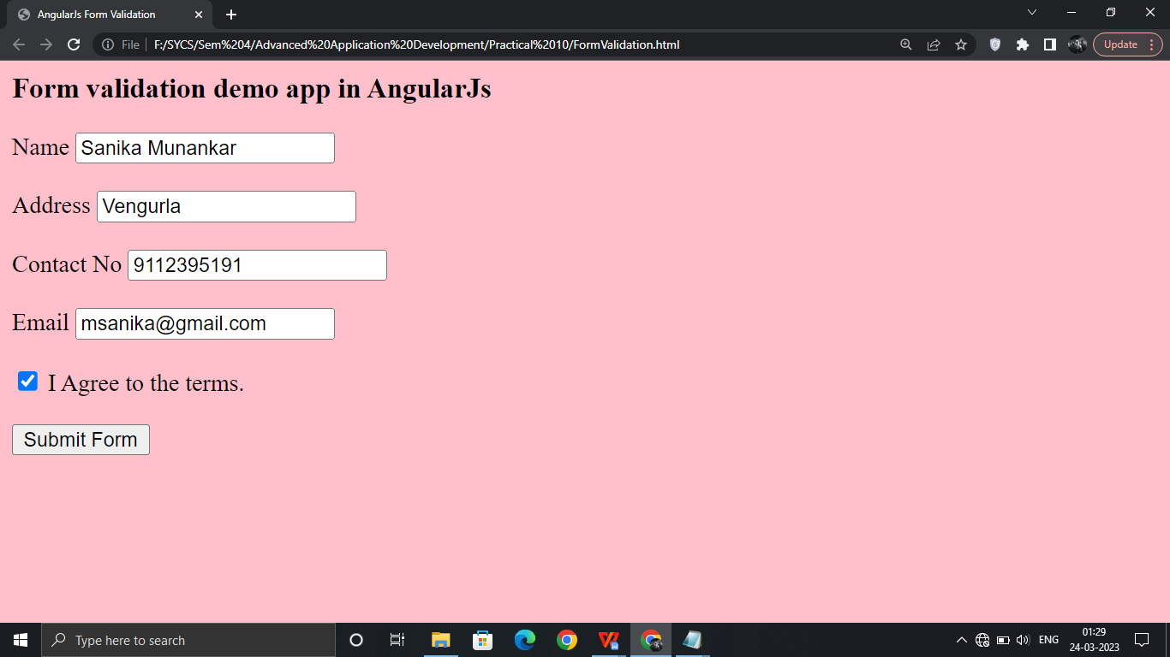

**After Clicking ‘Submit Form’**

